**abducted**

***Forensics***

**Challenge:**

I was going to just give you this flag, but the alien mothership downloaded it and deleted it from my computer!

We managed to get a snapshot of their mothership before it got away but it's in some weird proprietary format, can you find the flag they stole?

Primary Download Link: Download Here ‘https://drive.google.com/file/d/17DR9apPD9_6WRnwRgssEnQeNvzGdAY3p/view?usp=sharing’

Alternative Download Link: Download Here

‘https://drive.google.com/file/d/1NjozKNHIJpE-YZXQu3GPPGaJIBU8dsST/view?usp=sharing’

Alternative Split Archive Download Link: (All are required) https://krakenfiles.com/view/ofPAlvTaFa/file.html https://krakenfiles.com/view/0i0rQc5DMK/file.html https://krakenfiles.com/view/fpVnky7FTF/file.html https://krakenfiles.com/view/pYENIUwkPc/file.html https://krakenfiles.com/view/gDslSOv2Iz/file.html https://krakenfiles.com/view/S06syAzD1s/file.html

**Approach:**

So we’re given a logical image, and our task is to analyze the file. We’re going to use the tool FTKImager to check this file. We just click on File > Add Evidence Item and enter the source of the image File. Here’s how it looks once opened:

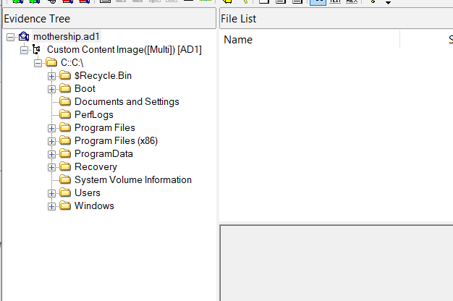

Now according to the question the mothership downloaded the file, so we go to the Users > mothership > Downloads and see this file:

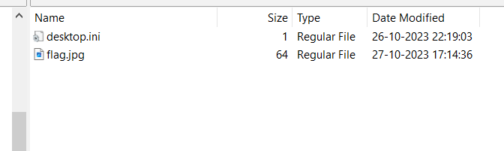

The flag.jpg contains the flag in it which is:

**Flag: NICC{15_TH15_C0N51D3R3D_4_R3C4PTUR3D_FL4G_N0W?}**

Congrats!!

Happy Hacking!